Datasheet

BRC1H52/82 Wired user interface with buzzer function and Bluetooth App
Table of Contents
1. Introduction 3
2. Overview of compatible Daikin units ranges 4
3. System layout 5
3.1 Typical layout 5
3.2 Typical layout for group control 5
3.2 Typical layout for group control (with optional sub UI or Digital Input Adapter board) 7
3.2.1 Main/Sub UI 7
3.2.2 Digital Input Adapter board 7
4. Specifications 8
4.1 Technical specifications 8
4.2 Available documentation 8
4.3 Outlook and dimensions 9
4.3.1 Outlook 9
4.3.2 Dimensions 9
4.4 Installation method 10
5 Summary of features 11
5.1 Basic user interface 11
5.2 Basic operation settings 11
5.3 R/C Interface Logic 12
5.4 Status and operation mode icons…………………………………………………………………….12
5.4.1 Status icons………………………………………………………………………………………….12
5.4.2 Operation mode icons………………………………………………………………………………13
5.5 Advanced operation settings to be set by App 13
5.5.2 Clock function 14
5.5.3 Schedule timer function 14
5.5.4 Energy Saving features 14
5.5.5 Button lock 15
5.5.6 Maintenance information 15
5.5.7 Quiet Mode & Demand Control 15
5.5.8 Duty Rotation and Backup 17
5.6 Options 18
5.6.1 Digital Input Adapter Board (BRP7A51/52/53/54) 18
5.6.2 Software Updater 18
5.7 Smartphone requirements, pairing, connection & features 19
5.7.1 Apple iOS 8.0 or higher 19
5.7.2 Android 5.0 or higher and Bluetooth Low Energy 4.2 or higher 19
6. Combination BRC1H51/81/519 & DIII central control equipment 20
7. Revision 21

1. Introduction

The wired user interface BRC1H52/82 allows the end user to control connected Daikin indoor units. The wired User Interface (UI) uses the P1P2 connection of the indoor unit to communicate.
A second UI can be connected to the same P1P2 connection. In this case one UI needs to be main and the other sub controller(*).

The BRC1H52/82 is the successor of the BRC1E*, BRC2E*, BRC3E* and BRC1H51/81/81*7/519/519*7
There were the BRC1E53 has one fits all interface, the BRC1H51/81/817/519/5197 has a split up interface which fits better the users:
- End user interface: European design, simplified, symbol driven, limited buttons, different colours
- Advance user and professional user: via App (Bluetooth low energy)
Towards BRC1H51/81/81*7/519/519*7 the BRC1H52/82 controller has a buzzer function to be used as legal requirement in combination with mini VRV R32 units

(*) The maximum wire length of P1P2 is limited to 500m

The BRC1H52/82 is not backwards compatible with the BRC1E*, BRC2E*, BRC3E* and BRC1H51/81/81*7/519/519*7

2. Overview of compatible Daikin units ranges

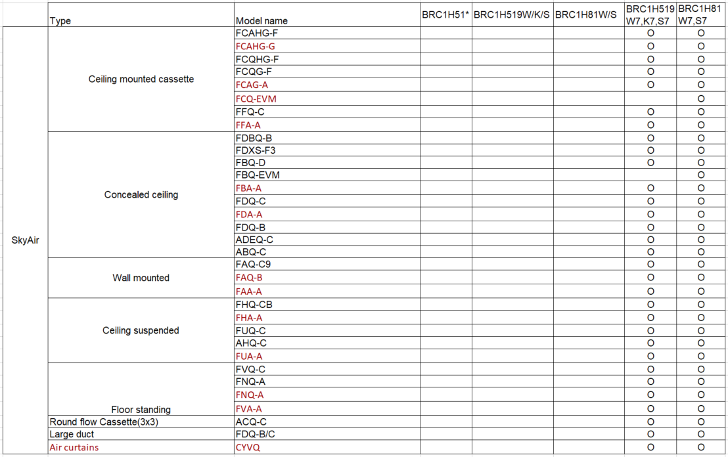
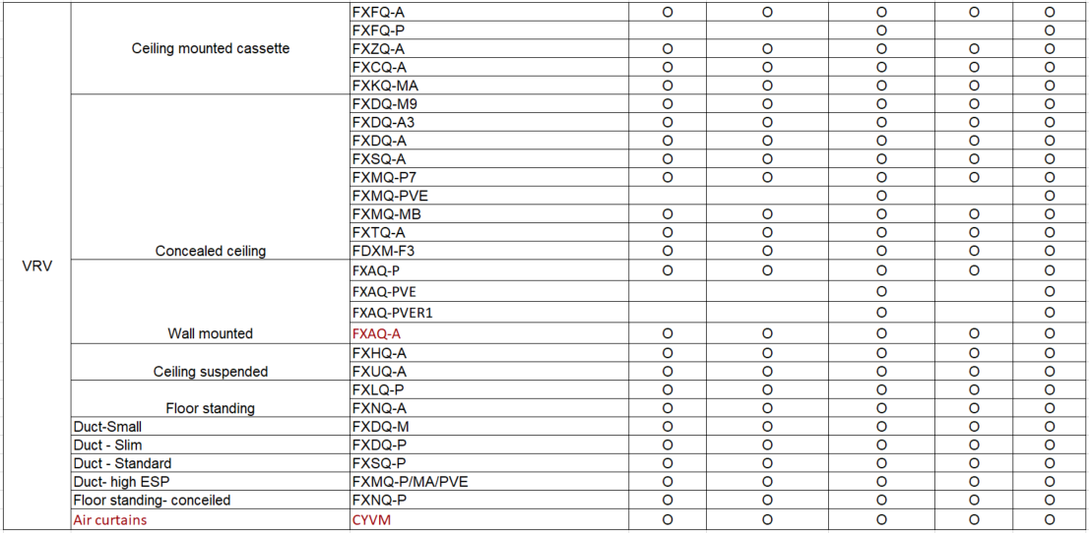
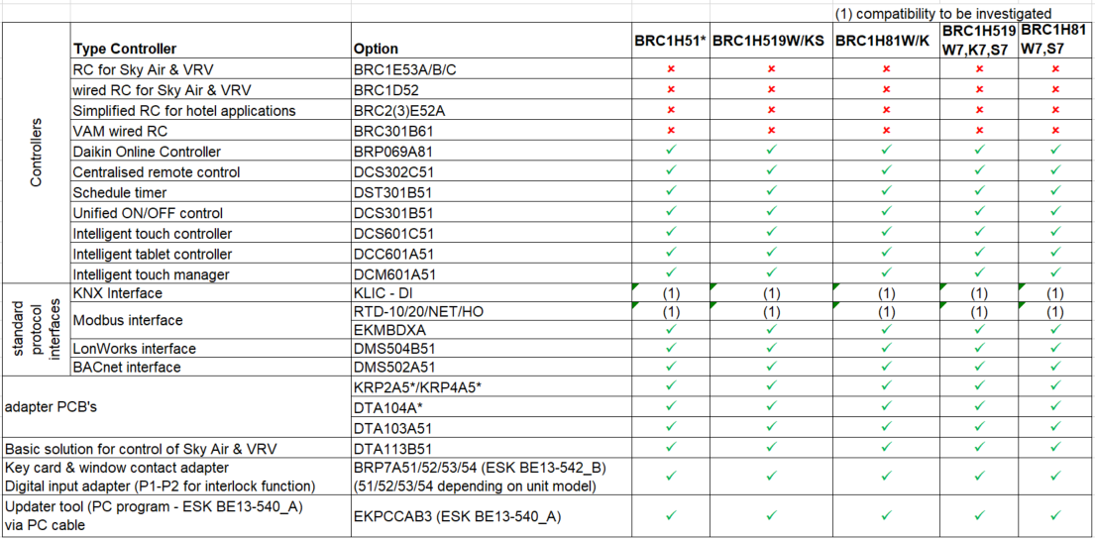
Note: for future product launches, refer to the respective data book of the new product or controller.

3. System layout

3.1 Typical layout
RA-indoor
S21
Adaptor
BRC073A1
Indoor Unit

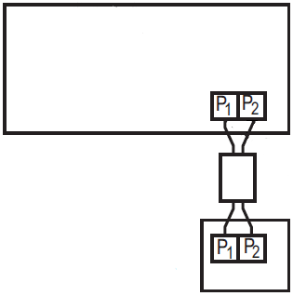

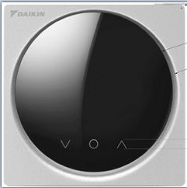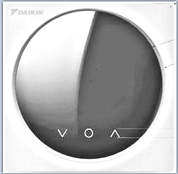

3.2 Typical layout for group control
Unit No. 2
Unit No. 1
Unit No. 0
Indoor Unit
Indoor Unit
Indoor Unit
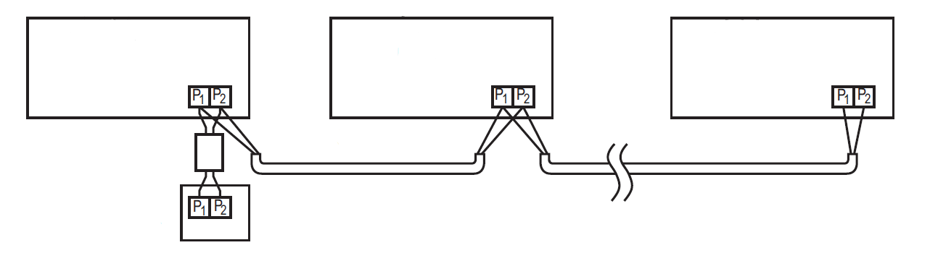

Note:
- Group control is required to be able to activate Duty Rotation & Backup.
- When using group control every unit is configured automatically with Unit No. (or address).
This number determines the rotation order.
To modify this number, contact your local dealer

3.2 Typical layout for group control (with optional sub UI or Digital Input Adapter board)

3.2.1 Main/Sub UI
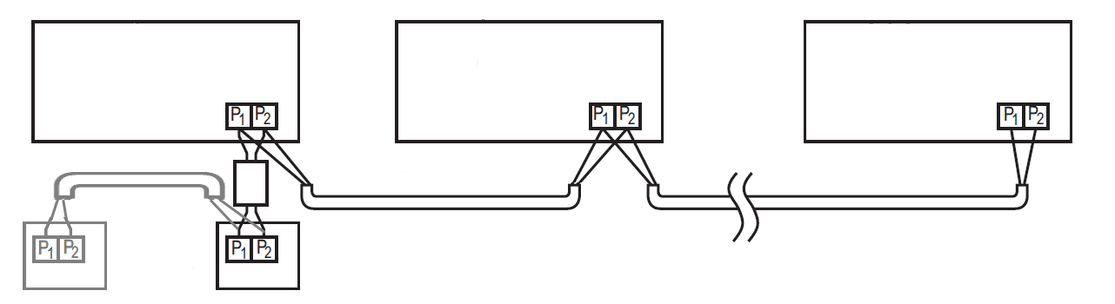
Unit No. 1
Unit No. 2
Unit No. 0
Indoor Unit
Indoor Unit
Indoor Unit
Sub UI
Main UI

3.2.2 Digital Input Adapter board
Unit No. 2
Unit No. 1
Unit No. 0
Indoor Unit
Indoor Unit
Indoor Unit
Digital Input
Adapter board
BRP7A5*

4. Specifications

4.1 Technical specifications

BRC1H52/82
Content
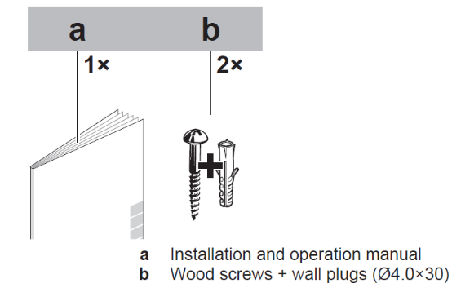
Dimensions | packing | h x w x d (mm) | 50 x 217 x 161
Dimensions | User interface | h x w x d (mm) | 85 x 85 x 25
Weight of user interface | net weight | g | 110
Weight of user interface | gross weight | g | 317
Weight of packing | material | g | Cardboard
Weight of packing | weight | g | 85
Ambient temperature | operation | °C | -10 ~ + 50 (indoor use)
Ambient temperature | storage | °C | -20 ~ + 70
Humidity |  |  | Below 95%RH
Colors |  |  | White (BRC1H*2W) /Black (BRC1H*2K) /Silver (BRC1H*2S)
Button cover |  |  | No
Operation lamp |  |  | BLUE STATUS INDICATOR
LCD size |  |  | 40,7 x 28,0 mm
LCD type |  |  | 100 x 150 Dots
Back light |  |  | Yes (white color)
Backup for power failure |  |  | yes  (The clock will keep functioning for period not  exceeding 48 hours)
P1P2 Connection | Wire type |  | Sheathed vinyl cord or cable
P1P2 Connection | Wire max. length | m | 500
P1P2 Connection | No. of conductors |  | 2
P1P2 Connection | Wire size | mm² | 0,75 – 1,25

4.2 Available documentation

Document | Contains … | Format
Installation and operation manual | Installation and operation instructions | Paper (in the box)
Installer and user reference guide | Preparation of installation, technical specifications, reference data, …  Detailed step-by-step instructions and background information for basic and advanced usage | Digital files on: http://www.daikineurope.com/support-and-manuals/product-information

4.3 Outlook and dimensions

4.3.1 Outlook

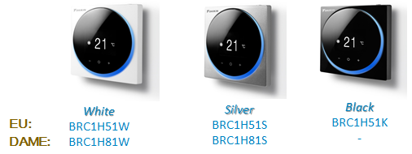

4.3.2 Dimensions

BRC1H51/81/817/519/5197 user interface (mm)
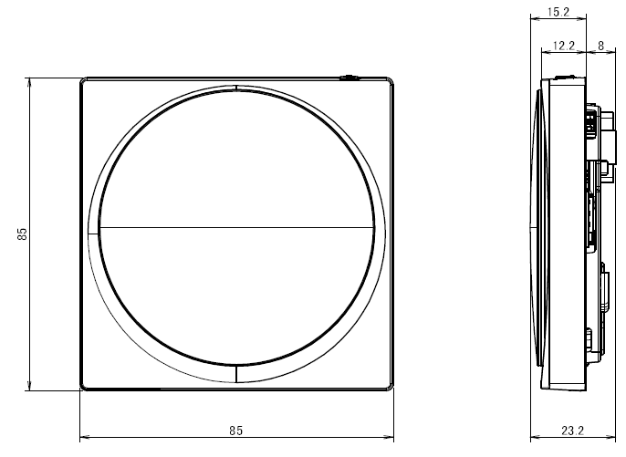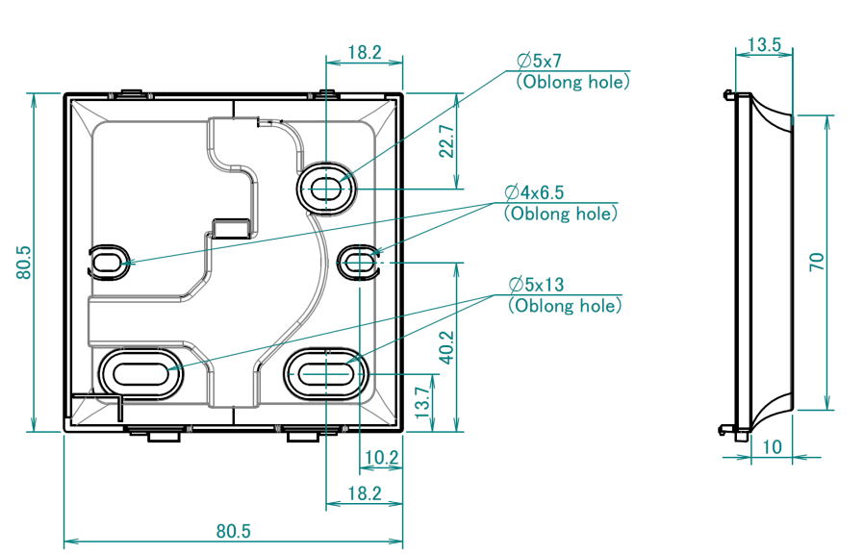

4.4 Installation method

To connect the electrical wiring:

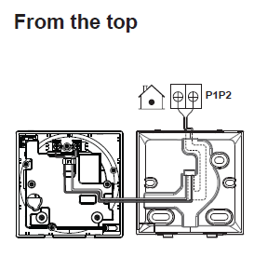 | 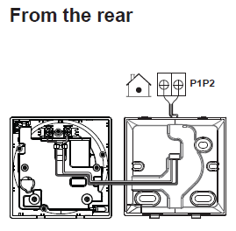
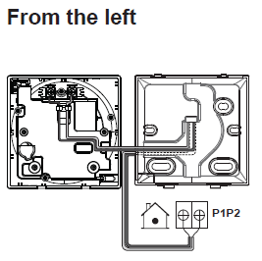 | 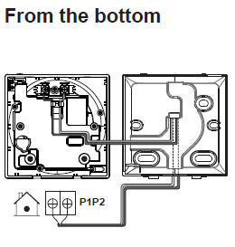

To mount the controller:

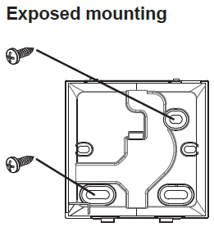 | 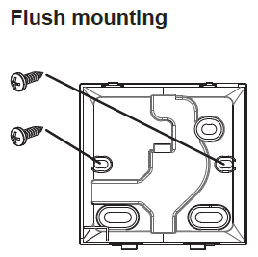

Easy Installation
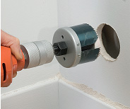
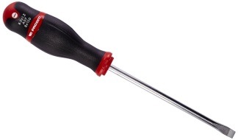
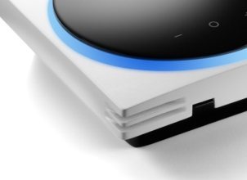
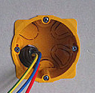
2 Pre-fitted openings:
  - Easy R/C opening
  - No risk of damage

5 Summary of features
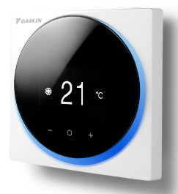

5.1 Basic user interface

The user interface is symbol driven (no text).
The basic userinteface functions are:
- On/off
- Operation mode change-over:

- Cooling / Heating or auto C/H change-over mode or fan only or dry mode
- (auto C/H change-over mode: cooling and heating adjustable temperature settings)
- Temperature adjustment (°C) during ON/OFF operation
- Airflow level (Fan speed) adjustment
- Airflow direction (Louvre/swing) adjustment
- Filter sign and reset
- Warnings and Errors

5.2 Basic operation settings

Direct buttons for:
- On/off button at the top of the remocon
- “O” Enter/Activate/Set
- From the home screen, enter the main menu
- From the main menu, enter one of the submenus
- From their respective submenu, activate a function
- In one of the submenus, confirm a setting
- “ - “ Cycle/ Adjust:
- Cycle left
- Adjust a setting (decrease)
- “+” Cycle/Adjust
- Cycle right:
- Adjust a setting (increase)
Others settings selectable via menu (by default accessable)

Display Selection (Simplified/detailed display mode)

Simplified view
Detailed view

Only setpoint value,
mode, and notifications
All relevant operation icons in
addition to mode & setpoint

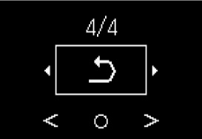
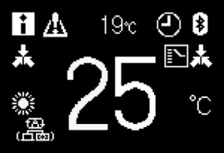
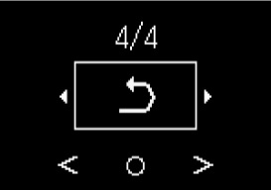
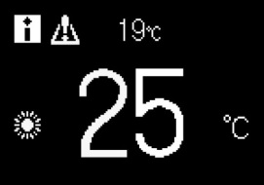

5.3 R/C Interface Logic

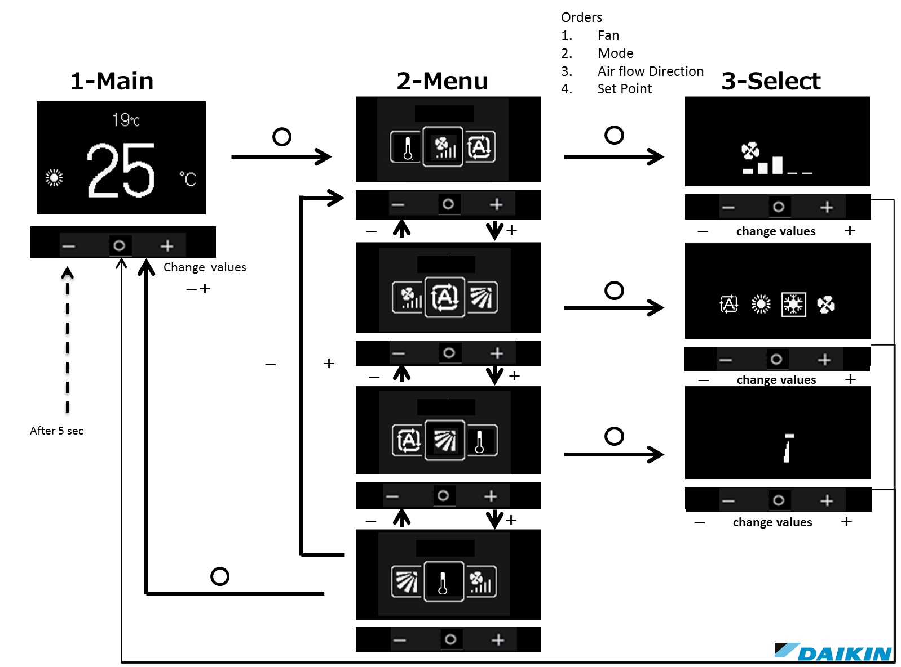

5.4 Status and operation mode icons

5.4.1 Status icons

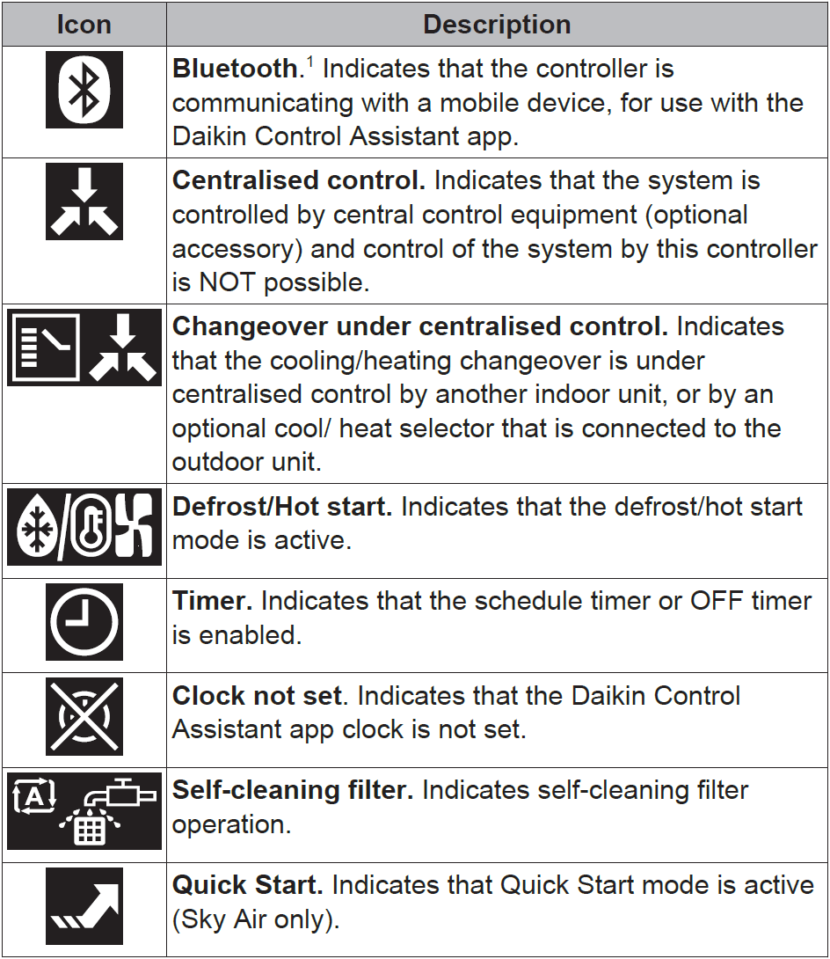 | 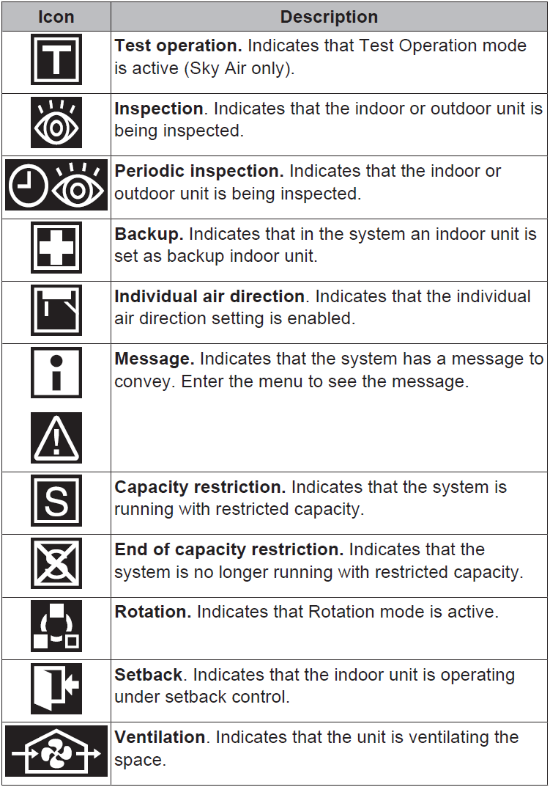
5.4.2 Operation mode icons

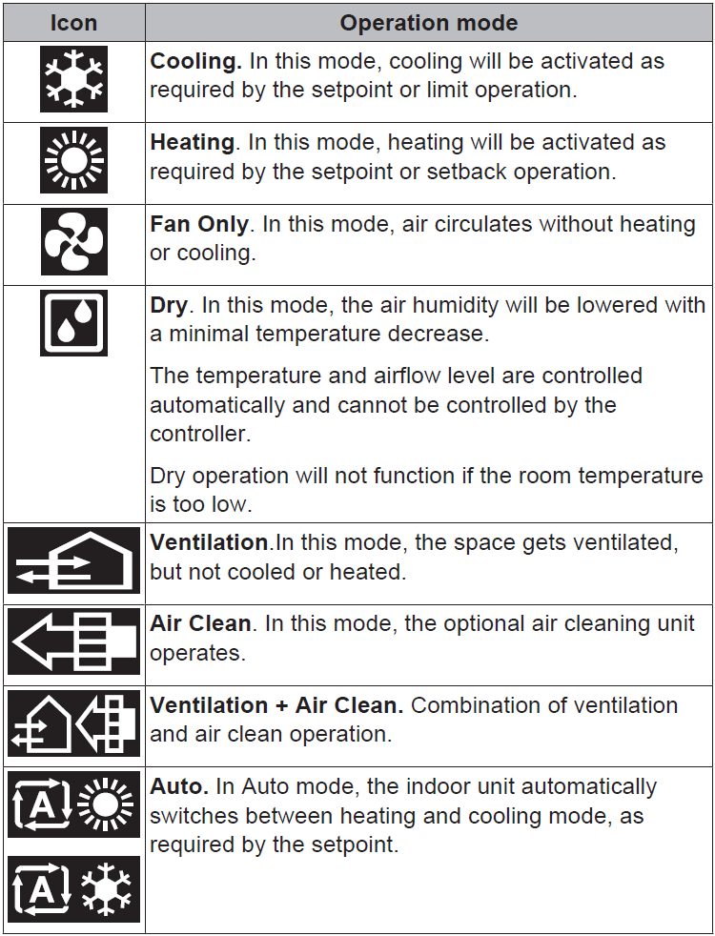

5.5 Advanced operation settings to be set by App
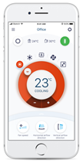

5.5.1 App features

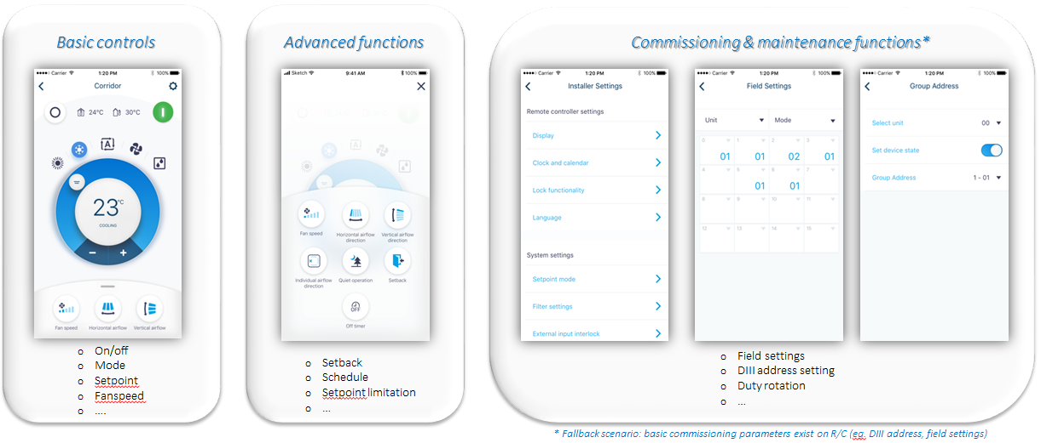

Basic controls & advanced functions: normal user
Commissioning & maintenance functions: facility manager/advance user and installers

5.5.2 Clock function

- Real time clock (display 12h or 24 h time format)
- Daylight saving time (summer/ winter time automatic change over)

5.5.3 Schedule timer function

- 3 independent schedules can be programmed: no. 1,2 & 3
(e.g. no. 1: summer schedule, no. 2: winter schedule , no. 3: intermediate schedule)
A maximum of 5 actions can be programmed for each day of the week (totalling 35 actions)
Schedule timer no. 1, no. 2 or no. 3 can be enabled/disabled at any time (but manual selection)
Each action linked to a Cooling and heating set temperature or OFF (with setback or without setback) operation
"last command" overrules previous command until next scheduled command
- Holiday function: the schedule timer will be disabled for days that have been set as holiday

Note: Schedule timer function is disabled in case a central controller or digital input adaptor board is installed.

5.5.4 Energy Saving features

- Setpoint range limitation: The setting temperature range can be restricted (between 16 – 32°C)
Separate range limitation in cooling mode, heating mode

For BRC1H82 minimum setpoint is limited to 20°C for UAE as this is ESMA regulation.
16°C setpoint low
20°C ->ESMA Requirement
32°C setpoint high
ESMA
Setpoint range
Standard
Setpoint range

- The setback feature will maintain the room temperature in a specific range during unoccupied periods.
Setback temperature range cooling 33° C till 37 °C, heating 10 °C till 15°C.
Setback is by default enabled.
Setback is possible when unit is switched off and setback is enabled.
Setback is applicable during heating & cooling by default or during heating only or during cooling only.
Setback setpoints can be changed when unit is switched off. Setback setpoints are shown in smaller digits.

Note: Setback should not be enabled when a central controller is connected.

- Presence sensor (if supported by the indoor unit and if present in the decoration panel(option))
Sensing energy save: setting temperature is automatically reduced (in heating) or increased (in cooling) when no people are detected during certain period.
Sensing stop set: turn off the unit when no people are detected during long period of time.

- Setting temperature auto reset:
Even if the setting temperature is changed, it returns to the pre-set temperature after a certain period

- Off timer: After you turn on the unit, it will automatically turn off after a certain period.

- Auto Display Off: When the system is switched off the blue status indicator is out

- Electricity consumption (only in case function is available on indoor unit):
(not available for indoor units connected in group control)
Indicative electricity consumption is graphical displayed
different screens: daily, weekly, monthly, yearly

5.5.5 Button lock

- Implementation only for mid July release. Behaviour not yet clear.

5.5.6 Maintenance information

When the filter is dirty, the system is in error, or the indoor unit needs to be maintained otherwise you press the menu button and see an error or maintenance screen upon trying to enter the main menu.
Contact your dealer and inform him the shown error code or symbol to resolve the issue.
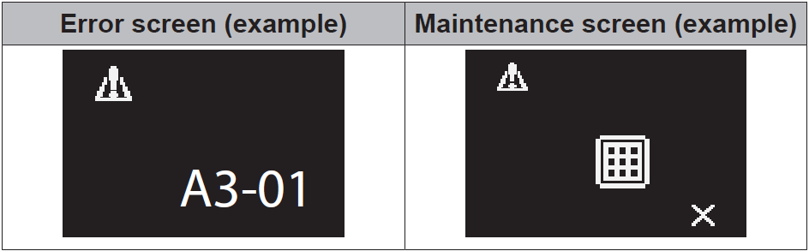

5.5.7 Quiet Mode & Demand Control

Remark: When the Quiet Mode or Demand Control mode is active the cooling or heating capacity of the system is reduced.

Quiet Mode:
A schedule can be made so that the Outdoor Unit produces less noise. If the outdoor unit supports this function then it is visible under Main menu \ Configuration.

Demand Control:
A schedule can be made so that the Outdoor Unit limits its energy consumption to 70 or 40% of the maximum energy consumption. If the outdoor unit supports this function then it is visible under Service Settings \ Demand.

5.5.8 Duty Rotation and Backup

This function is available if more than one unit is connected on the P1P2 connection (group control) of the user interface and if all these units support this function. This function is called ‘Rotation’ and is part of the main menu as a hidden menu item (push 4 seconds on the menu button to make it visible).

The Rotation function is designed for units operating in critical applications (e.g. in server rooms that
require lots of cooling). In this case, the system is equipped with an extra backup unit. Enabling
Rotation then allows for:
● Rotation: because the system is equipped with more units than are required to provide the heating/
cooling load, one of the units will remain inactive during normal operation. After a set time
(i.e. "Rotation cycle time", default 24h), the inactive unit will start operating and a previously active unit will
become inactive (i.e. duty rotation). Because the units are alternately allowed to take a break, the
lifespan of the system increases.
● Backup: having a backup unit allows for additional system redundancy. If an active unit goes into
error, Rotation makes sure the inactive one takes over.
● To let the backup unit reach its cooling/heating capacity, an overlap period is included in which
all units are active. (default 10min, configurable through field setting to 5’, 10’, 15’ or 30’)
If during the overlap period the cooling capacity is too high decrease the overlap time.
If after the overlap period the cooling capacity is too low increase the overlap time.
● The rotation order depends on the set Unit Number
● The indoor units need to be connected on one P1P2 connection to the user interface (group control)

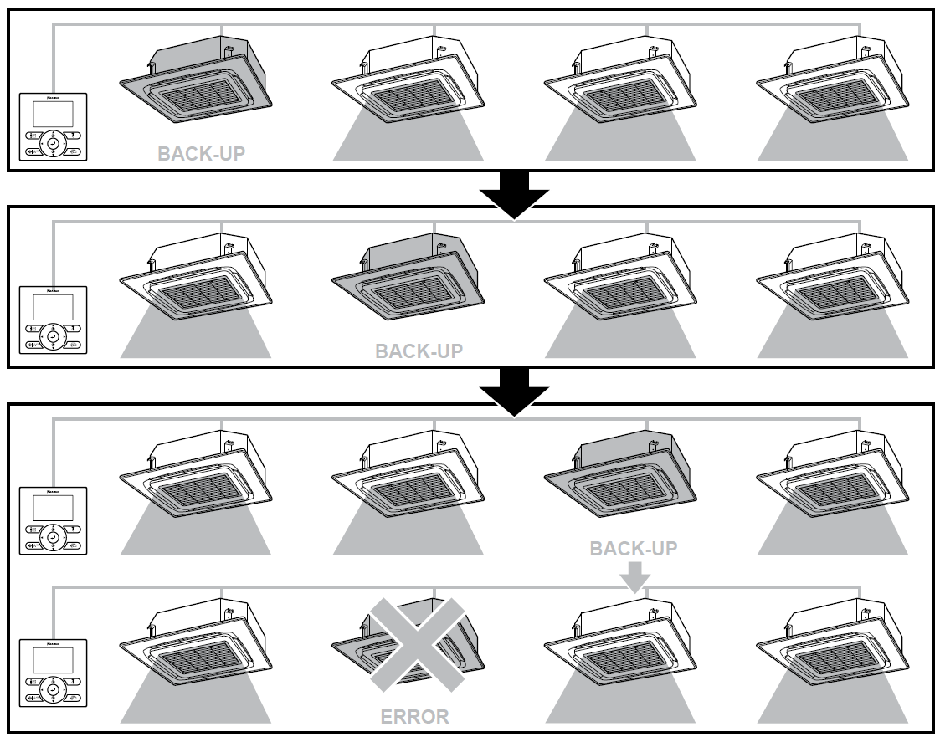

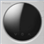
Large systems:
If the number of indoor units is too high (e.g.> 4) it is advised to create 2 (or more) groups of indoor units. Each group will then be under control of one UI and have one back-up unit. Each group will work independently and will have its own rotation cycle, overlap time and back-up unit.

This table shows –as a rule of thumb- the amount of units per group:
No. of indoor units | No. of groups | No. of Remocon | No. of Back-up Units
1 – 4 | 1 | 1 | 1
5 – 8 | 2 | 2 | 2
9 – 12 | 3 | 3 | 3
13 - 16 | 4 | 4 | 4

5.6 Options

5.6.1 Digital Input Adapter Board (BRP7A51/52/53/54)

Interlock with 2 external signals B1 & B2 (only in combination with BRP7A5* digital input adapter)
Remark: only a dry contact contact can be connected: Normally open or Normally closed.

Typical application: Offices or hotels interlock with field-supplied window contact B1

Remark:
- The interlock feature is explained in installer Reference Guide
- In case Interlock with external signals is installed, schedule timer function is disabled
- The digital input adapter needs to be connected to the P1P2 connection. In this case no sub User Interface can be connected.
- Depending on the indoor unit it might be required to use an installation box, mounting plate or casing (e.g. option KRP1BA101, KRP1H98,...) to mount the digital input adapter board.

5.6.2 Software Updater

With the ‘PC USB cable’ option EKPCCAB4 + updater software
Upgrade current model
Upload new software in case of issues
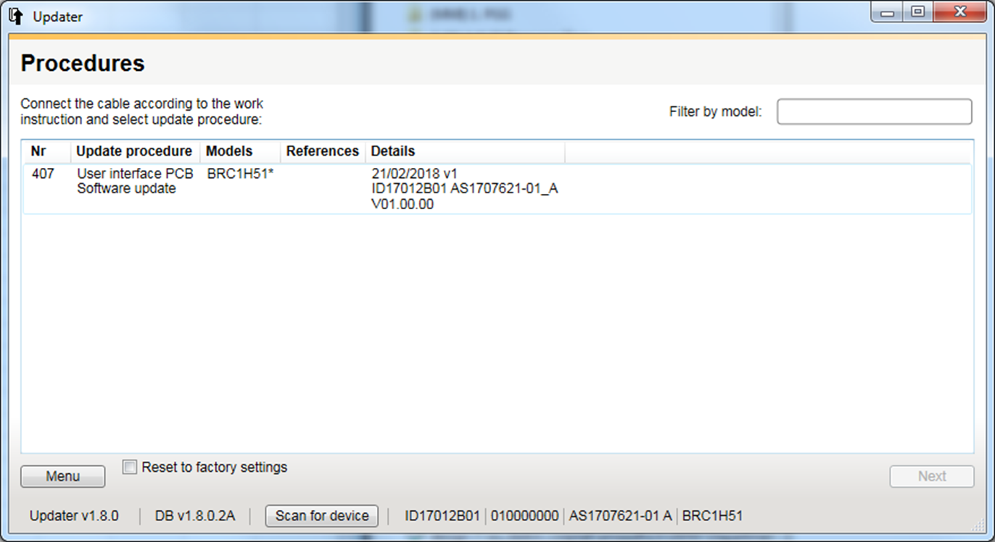
By entering model name possible updates are displayed.
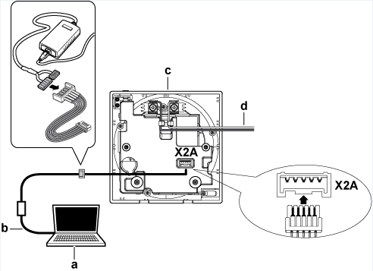

5.7 Smartphone requirements, pairing, connection & features


5.7.1 Apple iOS 8.0 or higher

Typical models are iPhone 4s and later, iPad 2 and later, all iPad minis and iPod Touch 5th generation and later

5.7.2 Android 5.0 or higher and Bluetooth Low Energy 4.2 or higher


5.7.3 Pairing

Advertising

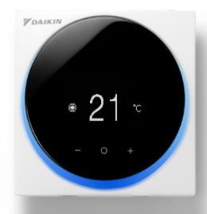
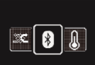
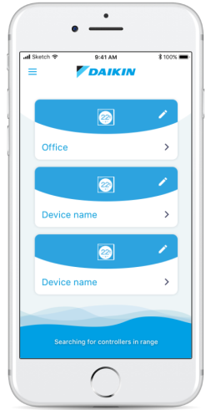





Numeric comparison: numeric value is on the R/C and the App to confirm pairing
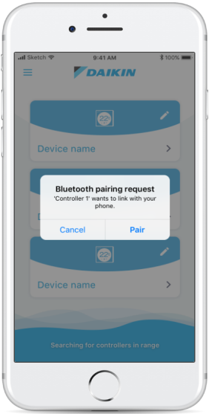

Number appearing on the app
For confirmation


5.7.4 App connection

Only one R/C can be connected to the App at the time Paired device are stored on the R/C & the App

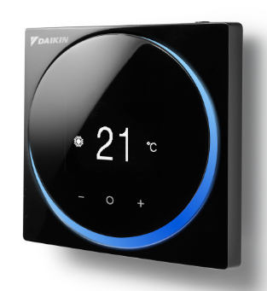
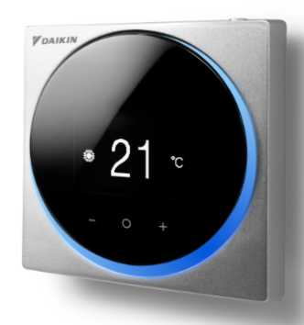
Up to 10 paired devices can be stored on the R/C

6. Combination BRC1H52/82 & DIII central control equipment

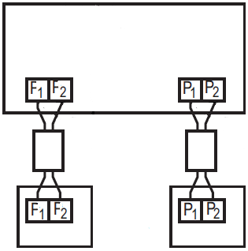
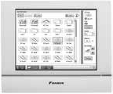

This configuration has impact on the following functions:
- Schedule timer function will be disabled on the remote controller
- Setback should not be enabled on the BRC1H (can be enabled on iTM for example)

7. Madoka R32 leak alarm

7.1 General logic

To comply with the R32 legislation the BRC1H52/82 has been equipped with a buzzer functionality.

Trough field settings three configurations are possible

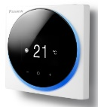
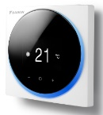
R/C + alarm
Applications requiring R/C
Applications not requiring R/C → Alarm only
Supervisor R/C -> alarm + visible indication

Supervisor
Alarm

Alarm function activation on:
- R/C + Alarm:
→Automatic activation of Alarm function when leak is detected. Based on the auto detection of the connected system type (R32/R410A), the Alarm functions are available or masked
→Indication is available on the information page of the app when connected to R32 system.
→Alarm function are manageable from R/C & APP ( see 7.2 R/C logic)

- Alarm:
→Automatic activation of Alarm function when leak is detected. Based on auto detection of the connected system type (R32/R410A), the Alarm functions are available or masked
→Indication is available on the information page of the app when connected to R32 system.
→ if Madoka PCB is used, alarm function are manageable from R/C hardware & APP (see 7.2 R/C logic)

- Surpervisor R/C:
In this case Madoka is used as central alarm for e.g. a lobby in a motel
→There is a visible and audible alarm
→ Info on the alarm origin. Which indoor unit has the leakage alarm
→ Other errors, not related on the leakage alarm, can also be shown on this supervisor R/C
→ It’s NOT possible to turn of the local alarm of the indoor unit directly from supervisor R/C

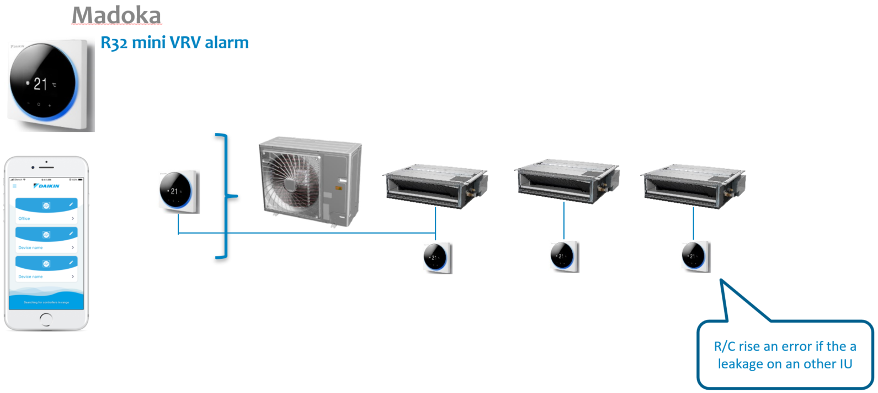

What happens when a leak is detected:

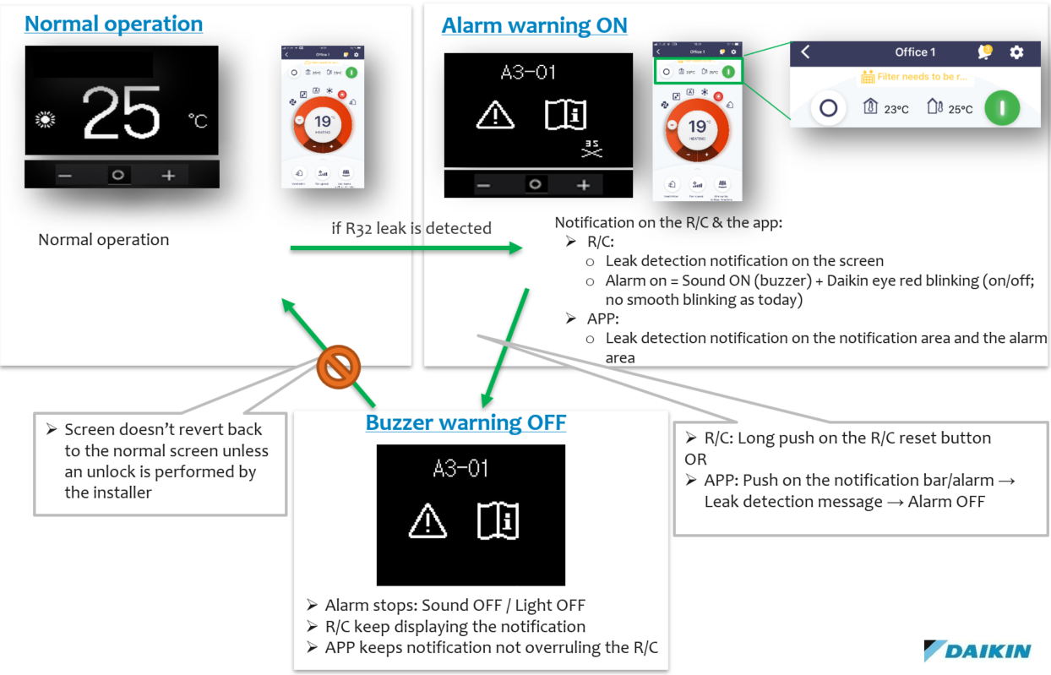

7.2 Compatibility with other controller

7.2.1 Central control connection

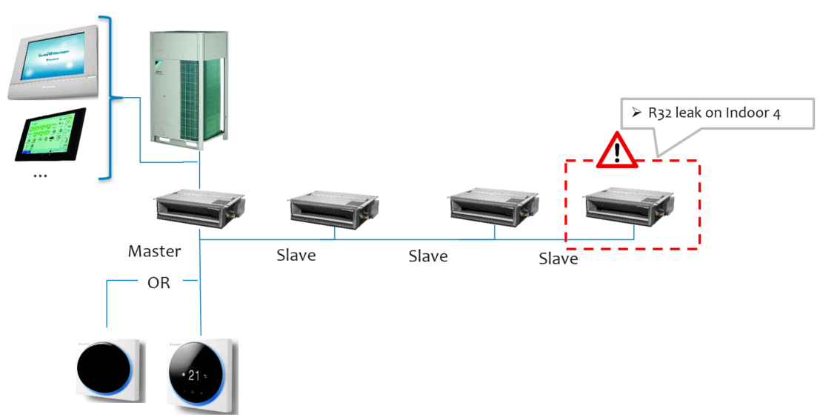

7.2.2 Slave controller/gateways combination

Gateways as KNX/RTD’s/KRP are compatible with BRC1H52/82 but only in “Slave” combination

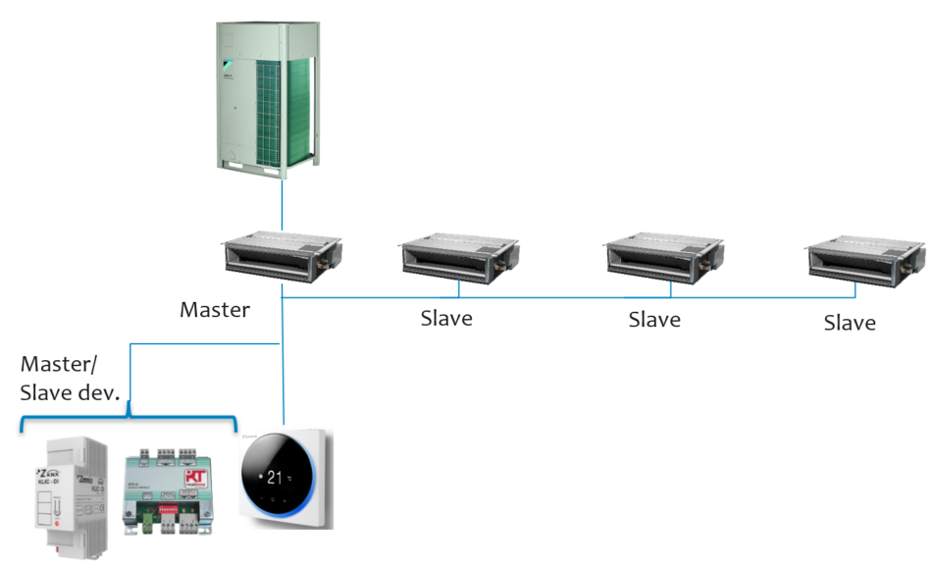

7.2.3 Wireless R/C combination
The wireless controller is compatible with the R32 system as “Slave” device

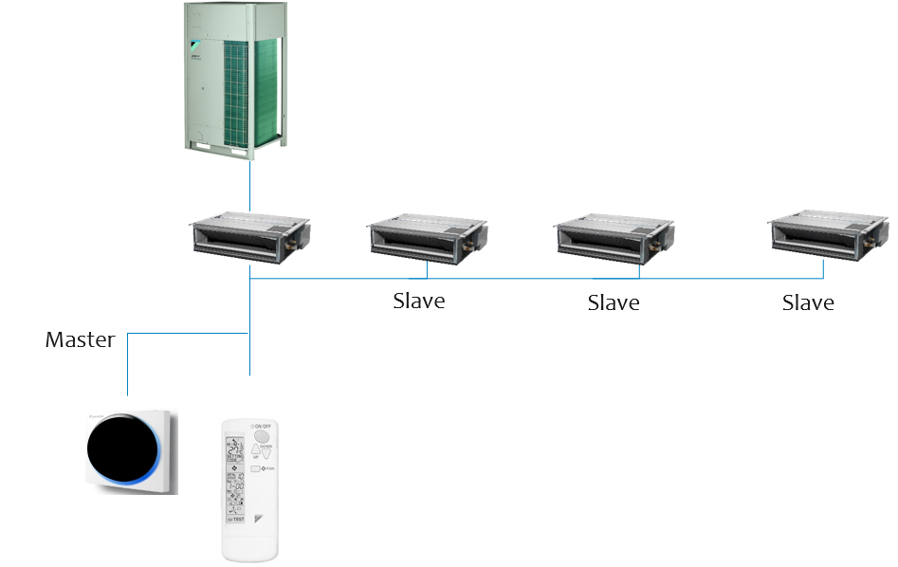

8. Revision

27/11/2019 | D. De Smeyter | Rev 0.1 Draft based on BRC1H51/81/81*7/519/519*7 datasheet
28/11/2019 | D. De Smeyter | Rev 1.0 first release

